

**CSE2007 : Database Management Systems**

**Name :** Gudi Varaprasad

**Reg. No. :** 19BCE7048

School of Computer Science and Engineering

**Lab Slot :** L45 + L46

**Date :** 25 – 03 – 2021

**Submitted to :** Ms. Dhanavanthini madam

**Practice SQL Queries**

**1. Display the details of all employees**

> Select * from emp;

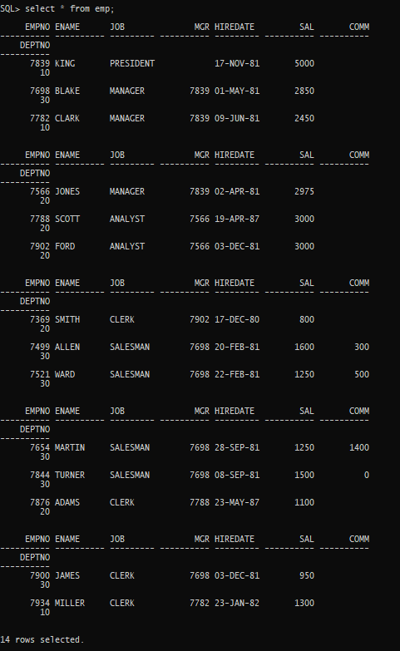

**2. Display the depart information from department table**

> select * from dept;

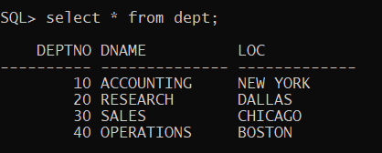

**3. Display the name and job for all the employees**

> select ename,job from emp;

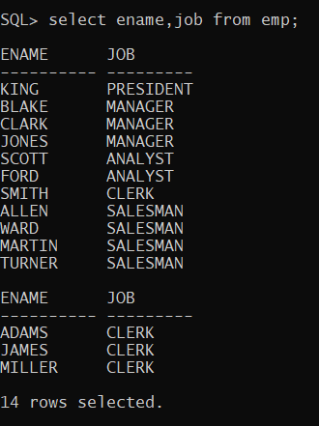

**4. Display the name and salary for all the employees**

> select ename,sal from emp;

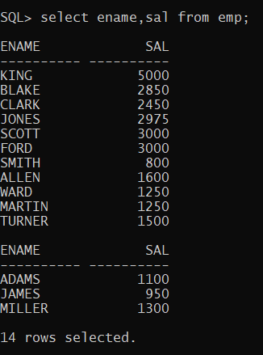

**5. Display the employee no and total salary for all the employees**

> select empno,ename,sal,comm, sal+nvl(comm,0) as "total salary" from emp;

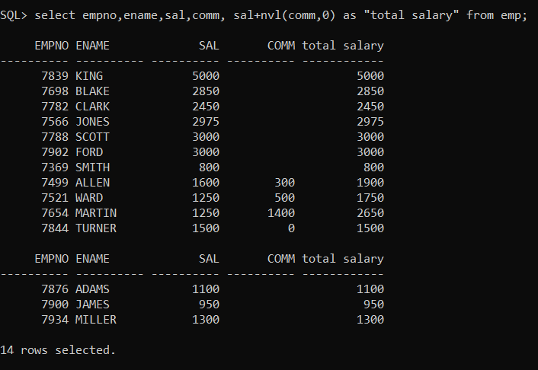

**6. Display the employee’s name and annual salary for all employees.**

**>** **select ename, 12*(sal+nvl(comm,0)) as “annual Sal” from emp;**

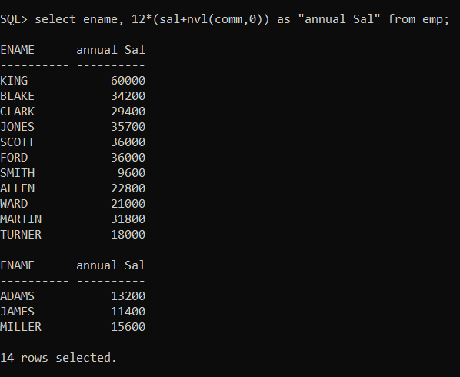

**7. Display the names of all the employees who are working in depart number 10.**

> select ename from emp where deptno=10;

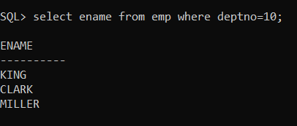

**8. Display the names of all the employees who are working as clerks and drawing a salary more than 3000.**

> select ename from emp where job=’CLERK’ and sal>3000;

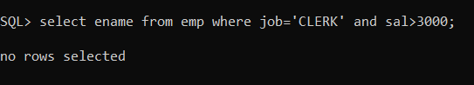

**9. Display the employee number and name who are earning comm.**

> select empno,ename from emp where comm is not null;

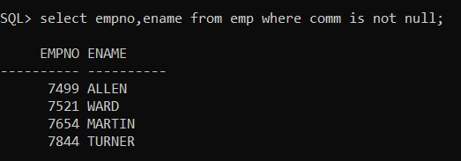

**10. Display the employee number and name who do not earn any comm.**

**> select empno,ename from emp where comm is null;**

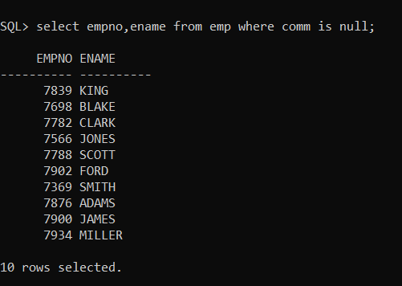

**11. Display the names of employees who are working as clerks, salesman or analyst and drawing a salary more than 3000.**

> select ename from emp where job='CLERK' OR JOB='SALESMAN' OR JOB='ANALYST' AND SAL>3000;

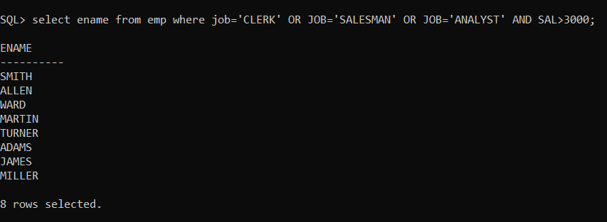

**12. Display the names of the employees who are working in the company for the past 5 years;**

**> select ename from emp where to_char(sysdate,'YYYY') to_char(hiredate,'YYYY')>=5;**

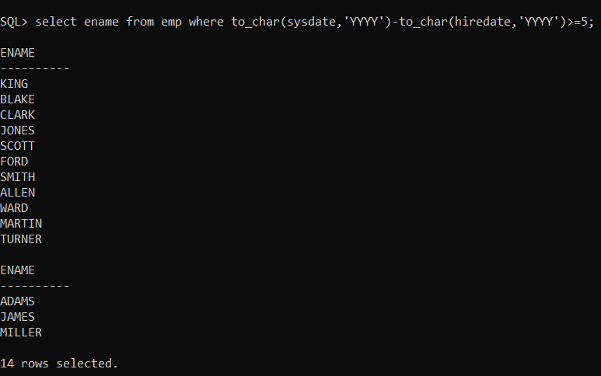

**13. Display the list of employees who have joined the company before 30-JUN-90 or after 31-DEC-90.**

> select ename from emp where hiredate < '30-JUN-1990' or hiredate >'31-DEC-90';

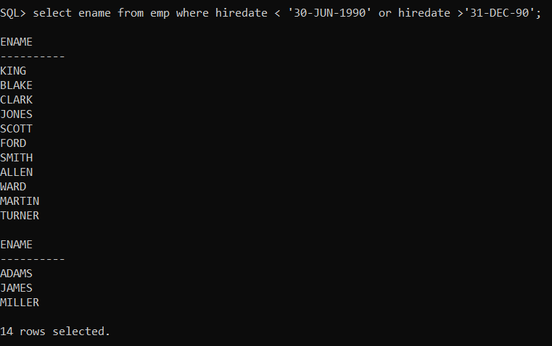

**14. Display current Date.**

> select sysdate from dual;

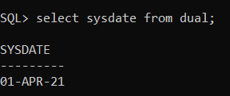

**15. Display the list of all users in your database(use catalog table).**

> select username from all_users;

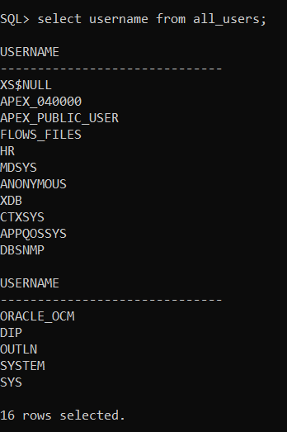

**16. Display the names of all tables from current user;**

> select tname from tab;

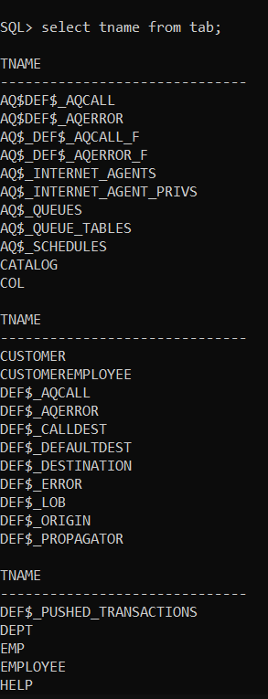 **...……** 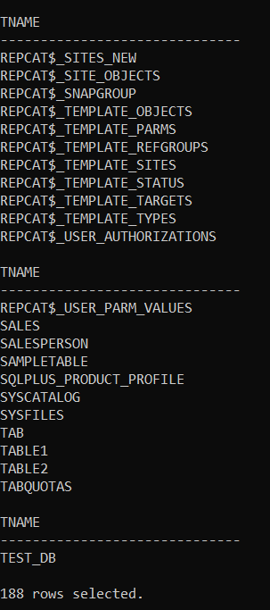

**17. Display the name of the current user.**

> show user;

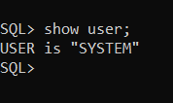

**18. Display the names of employees working in depart number 10 or 20 or 40 or employees working as CLERKS,SALESMAN or ANALYST.**

> select ename from emp where deptno in(10,20,40) or job in('CLERKS','SALESMAN','ANALYST');

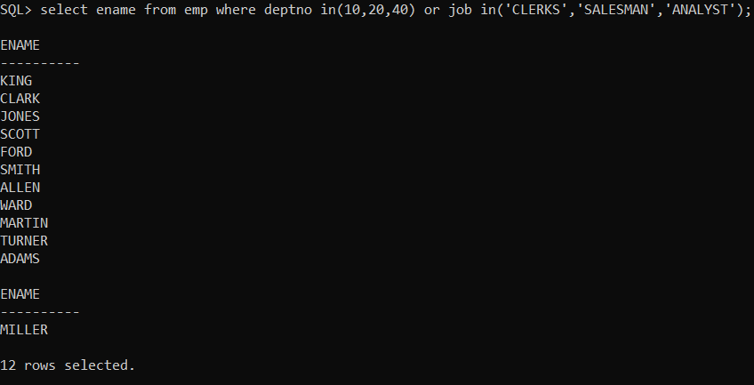

**19. Display the names of employees whose name starts with alphabet S.**

> select ename from emp where ename like 'S%';

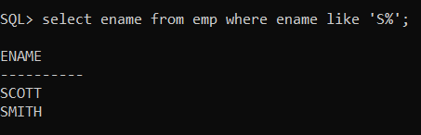

**20. Display the Employee names for employees whose name ends with alphabet S.**

> select ename from emp where ename like '%S';

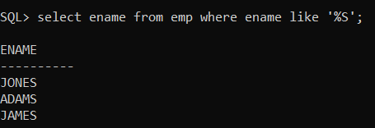

**21. Display the names of employees whose names have second alphabet A in their names.**

> select ename from emp where ename like '_A%';

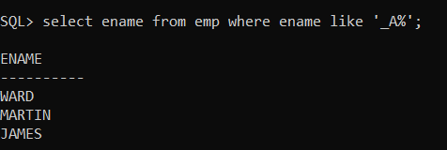

**22. Select the names of the employee whose names is exactly five characters in length.**

> select ename from emp where length(ename)=5;

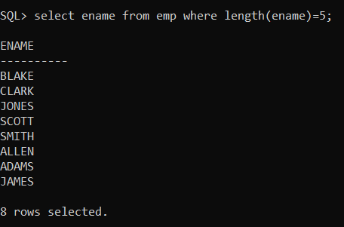

**23. Display the names of the employee who are not working as MANAGERS.**

> select ename from emp where job not in('MANAGER');

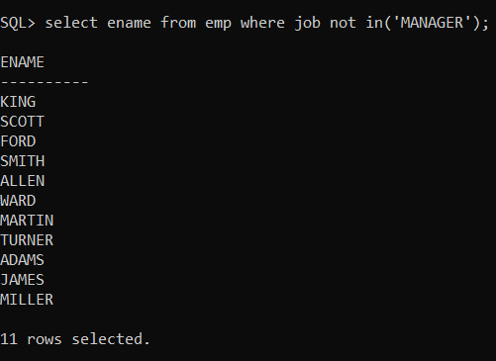

**24. Display the names of the employee who are not working as SALESMAN OR CLERK OR ANALYST.**

> select ename from emp where job not in('SALESMAN','CLERK','ANALYST');

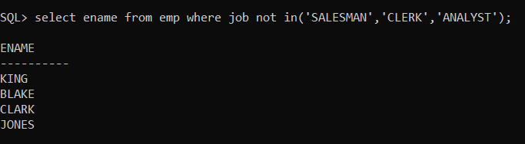

**25. Display all rows from emp table. The system should wait after every screen full of information.**

> set pause on;

> set pause off;

**26. Display the total number of employee working in the company.**

> select count(*) from emp;

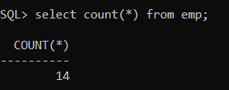

**27. Display the total salary being paid to all employees.**

> select sum(sal) from emp;

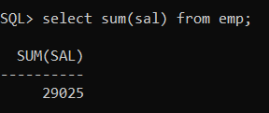

**28. Display the maximum salary from emp table.**

> select max(sal) from emp;

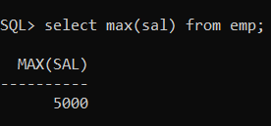

**29. Display the minimum salary from emp table.**

**> select min(sal) from emp;**

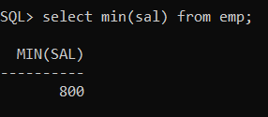

**30. Display the average salary from emp table.**

**> select avg(sal) from emp;**

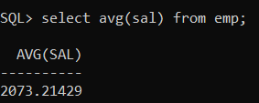

**31. Display the maximum salary being paid to CLERK.**

**> select max(sal) from emp where job='CLERK';**

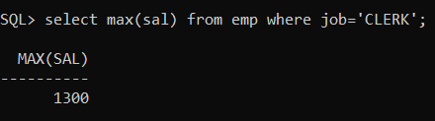

**32. Display the maximum salary being paid to depart number 20.**

**> select max(sal) from emp where deptno=20;**

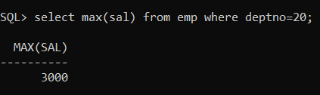

**33. Display the minimum salary being paid to any SALESMAN.**

**> select min(sal) from emp where job='SALESMAN';**

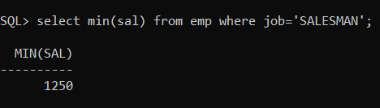

**34. Display the average salary drawn by MANAGERS**

**> select avg(sal) from emp where job='MANAGER';**

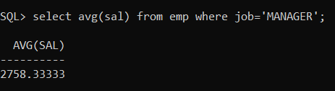

**35. Display the total salary drawn by ANALYST working in depart number 40.**

> select sum(sal) from emp where job='ANALYST' and deptno=40;

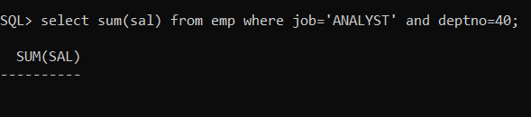

**36. Display the names of the employee in order of salary i.e the name of**

**the employee earning lowest salary should salary appear first.**

> select ename from emp order by sal;

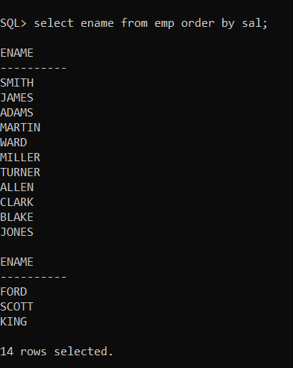

**37. Display the names of the employee in descending order of salary.**

**> select ename from emp order by sal desc;**

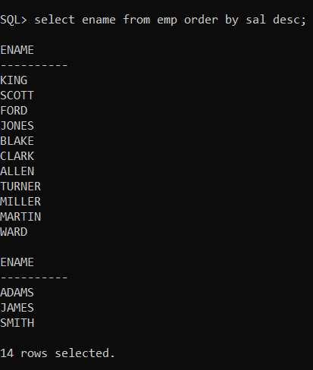

**38. Display the names of the employee in order of employee name.**

**> select ename from emp order by ename;**

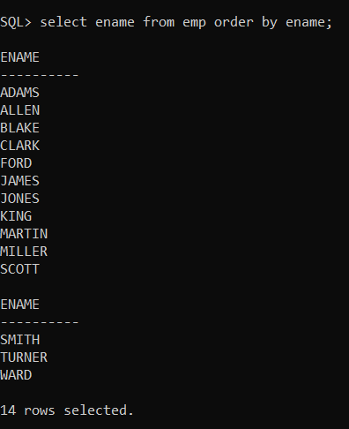

**39. Display empno, ename, deptno, sal sort the output first based on name and within name by deptno and within deptno by sal.**

> select empno,ename,deptno,sal from emp order by ename,deptno,sal;

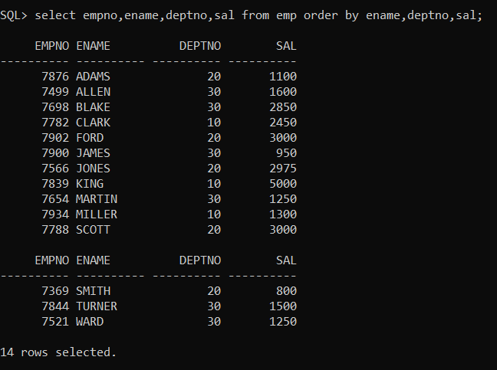

**40. Display the name of the employee along with their annual salary(sal*12).The name of the employee earning highest annual salary should appear first.**

> select ename,sal*12 from emp order by sal desc;

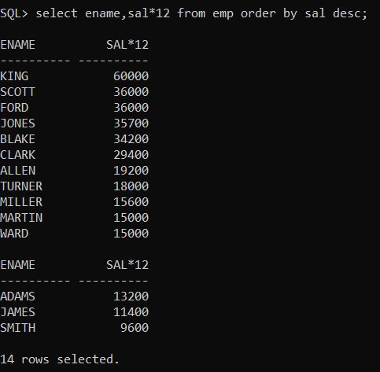

**41. Display name, salary, hra, pf, da, total salary for each employee. The output should be in the order of total salary, hra 15% of salary, da 10% of salary, pf 5% salary, total salary will be(salary + hra + da)-pf.**

> select ename,sal,sal/100*15 as hra,sal/100*5 as pf,sal/100*10 as da, sal+sal/100*15+sal/100*10-sal/100*5 as total from emp;

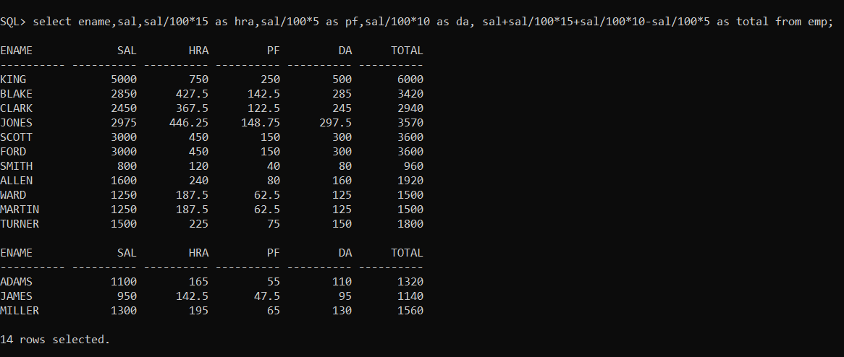

**42. Display depart numbers and total number of employees working in each department.**

> select deptno,count(deptno)from emp group by deptno;

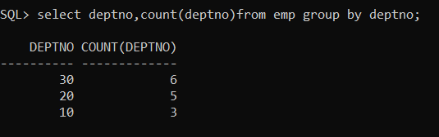

**43. Display the various jobs and total number of employees within each job group.**

**> select job,count(job)from emp group by job;**

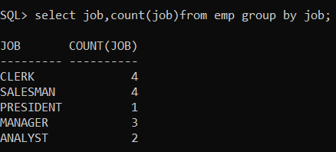

**44. Display the depart numbers and total salary for each department.**

> select deptno,sum(sal) from emp group by deptno;

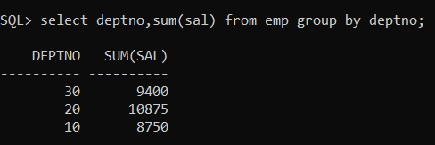

**45. Display the depart numbers and max salary for each department.**

> select deptno,max(sal) from emp group by deptno;

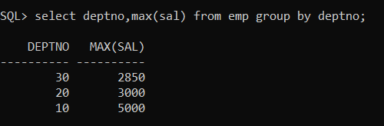

**46. Display the various jobs and total salary for each job**

> select job,sum(sal) from emp group by job;

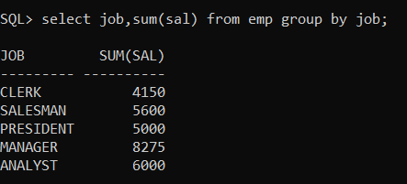

**47. Display the various jobs and minimum salary for each job**

> select job,min(sal) from emp group by job;

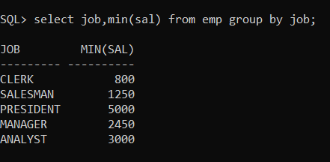

**48. Display the depart numbers with more than three employees in each dept.**

> select deptno,count(deptno) from emp group by deptno having count(*)>3;

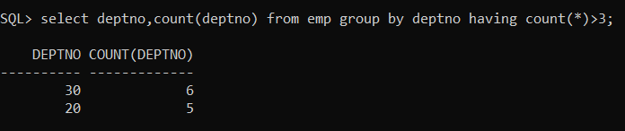

**49. Display the various jobs along with total salary for each of the jobs where total salary is greater than 4000.**

> select job,sum(sal) from emp group by job having sum(sal)>4000;

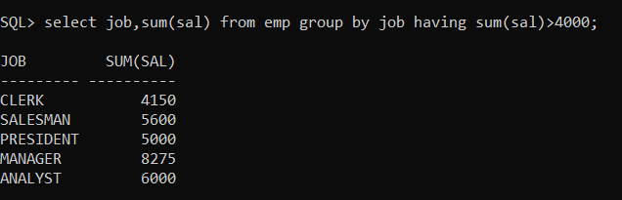

**50. Display the various jobs along with total number of employees in each job. The output should contain only those jobs with more than three employees.**

> select job,count(empno) from emp group by job having count(job)>3;

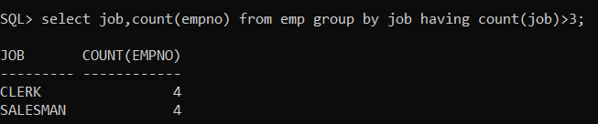

**51. Display the name of the employee who earns highest salary.**

> select ename from emp where sal=(select max(sal) from emp);

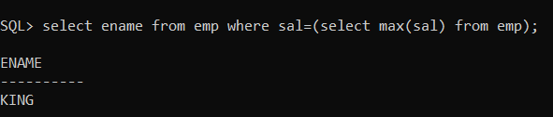

**52. Display the employee number and name for employee working as clerk and earning highest salary among clerks.**

> select empno,ename from emp where job='CLERK' and sal=(select max(sal) from emp where job='CLERK');

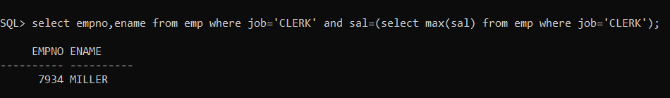

**53. Display the names of salesman who earns a salary more than the highest salary of any clerk.**

> select ename,sal from emp where job='SALESMAN' and sal>(select max(sal) from emp where job='CLERK');

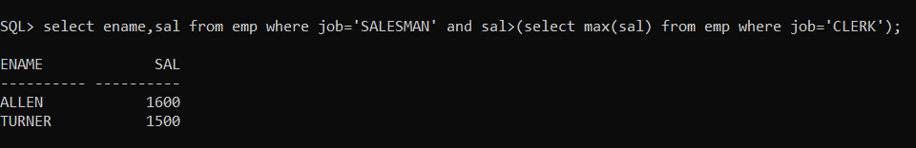

**54. Display the names of clerks who earn a salary more than the lowest salary of any salesman**

> select ename from emp where job='CLERK' and sal>(select min(sal) from emp where job='SALESMAN');

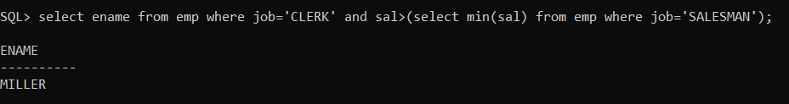

**Display the names of employees who earn a salary more than that of**

**Jones or that of salary greater than that of Scott.**

> select ename,sal from emp where sal> (select sal from emp where ename='JONES')and sal> (select sal from emp where ename='SCOTT');

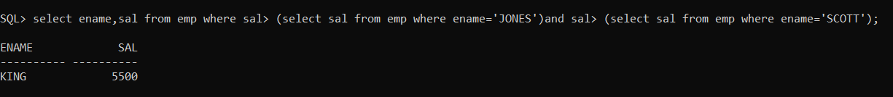

**55. Display the names of the employees who earn highest salary in their respective departments**

> select ename,sal,deptno from emp where sal in(select max(sal) from emp group by deptno);

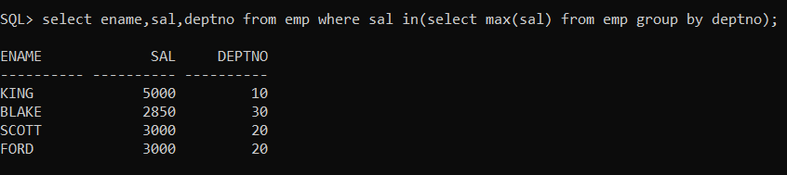

**56. Display the names of the employees who earn highest salaries in their respective job groups**

> select ename,sal,job from emp where sal in(select max(sal) from emp group by job);

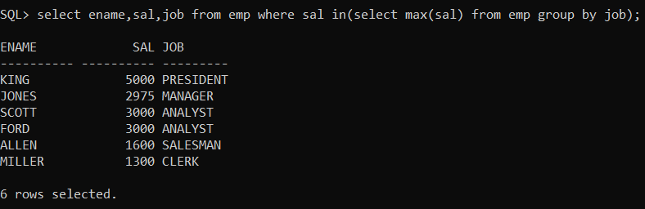

**57. Display the employee names who are working in accounting department.**

> select ename from emp where deptno=(select deptno from dept where dname='ACCOUNTING');

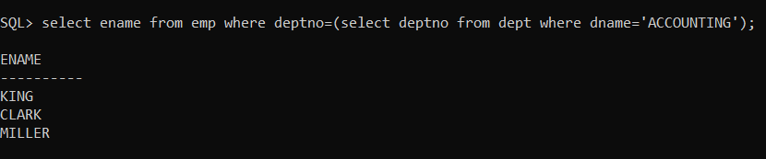

**58. Display the employee names who are working in Chicago.**

> select ename from emp where deptno=(select deptno from dept where LOC='CHICAGO');

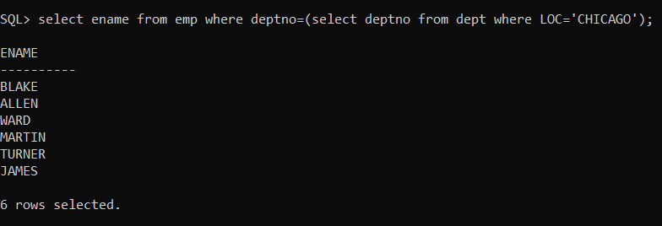

**59. Display the Job groups having total salary greater than the maximum salary for managers.**

> SELECT JOB,SUM(SAL) FROM EMP GROUP BY JOB HAVING SUM(SAL)>(SELECT MAX(SAL) FROM EMP WHERE JOB='MANAGER');

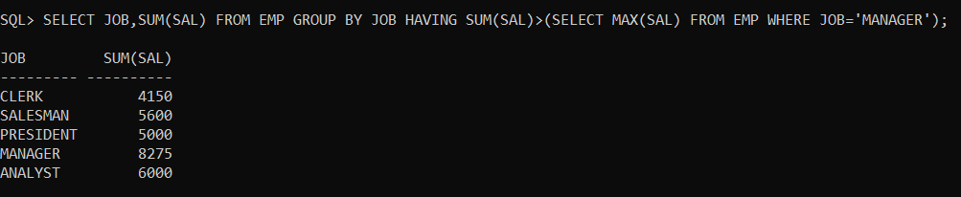

**60. Display the names of employees from department number 10 with salary greater than that of any employee working in other department.**

> select ename from emp where deptno=10 and sal>any(select sal from emp where deptno not in 10);

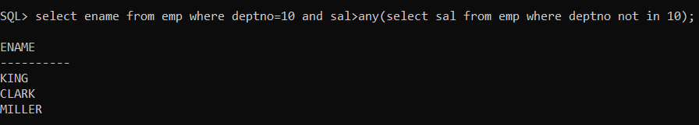

**61.** **Display the names of the employees from department number 10 with salary greater than that of all employee working in other departments.**

> select ename from emp where deptno=10 and sal>all(select sal from emp where deptno not in 10);

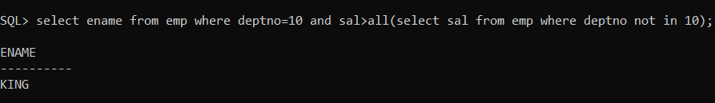

**62. Display the names of the employees in Uppercase.**

> select upper(ename)from emp;

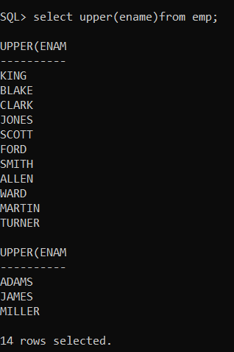

**63. Display the names of the employees in Lowercase.**

> select lower(ename)from emp;

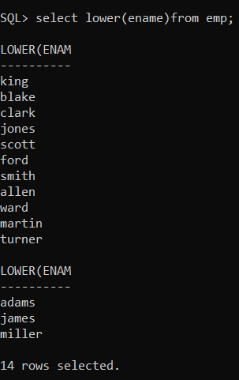

**64. Display the names of the employees in Proper case.**

> select initcap(ename)from emp;

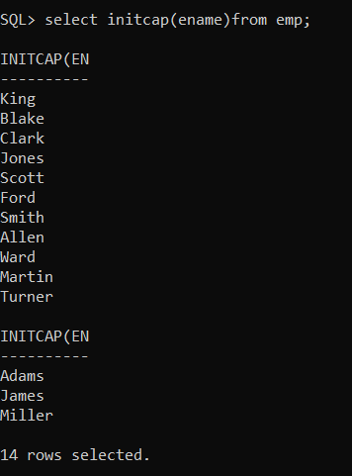

**65. Display the length of Your name using appropriate function.**

> select length('Varaprasad') from dual;

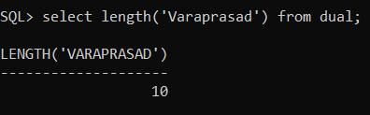

**66. Display the length of all the employee names**

> select length(ename) from emp;

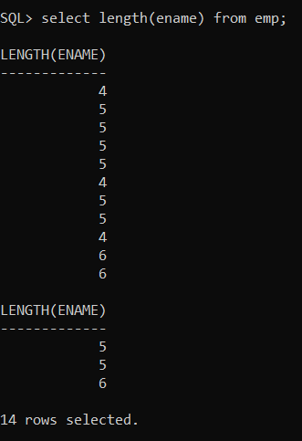

**67. Select name of the employee concatenate with employee number.**

> select ename||empno from emp;

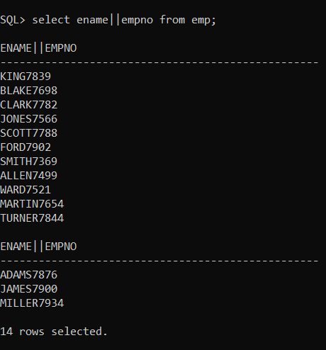

**68. User appropriate function and extract 3 characters starting from 2 characters from the following string 'Oracle'. i.e the output should be 'ac'.**

> select substr('oracle',3,2) from dual;

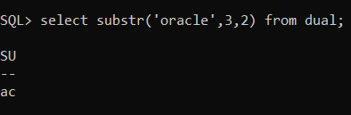

**69. Find the First occurrence of character 'a' from the following string i.e 'Computer Maintenance Corporation'.**

> SELECT INSTR('Computer Maintenance Corporation','a',1) as "1st occurrence" FROM DUAL;

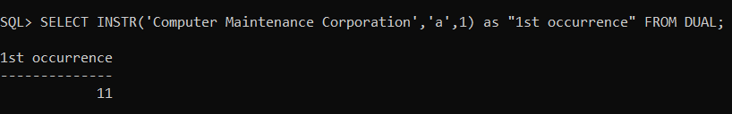

**70. Replace every occurrence of alphabet A with B in the string Allens(use translate function)**

> select translate('Allens','A','B') from dual;

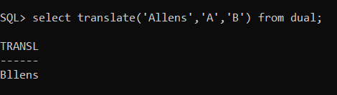

**71. Display the information from emp table. Where job manager is found it should be displayed as boos(Use replace function).**

> select replace(JOB,'MANAGER','BOSS') FROM EMP;

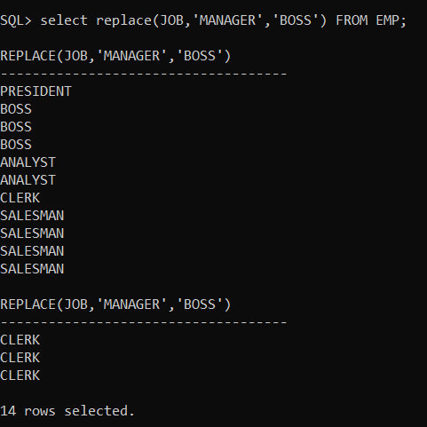

**72. Display empno, ename, deptno from emp table. Instead of display department numbers display the related department name(Use decode function).**

> select empno,ename,decode (deptno,10,'ACCOUNTING',20,'RESEARCH',30,'SALES',40,'OPRATIONS') from emp;

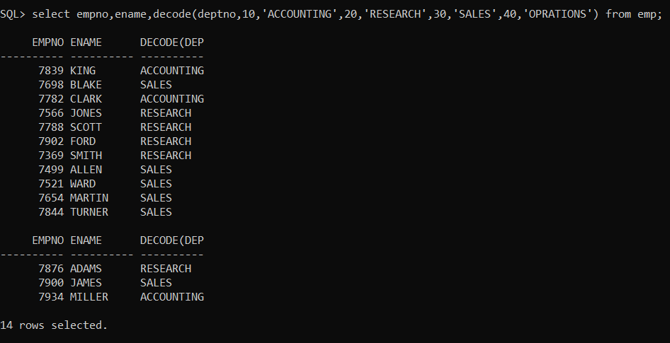

**73. Display your age in days.**

> select to_date(sysdate)-to_date('22-oct-01') as "Total Days" from dual;

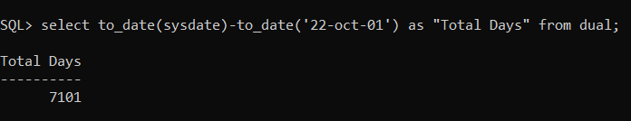

**74. Display your age in months.**

> select months_between(sysdate,'22-oct-01') as "Total Months" from dual;

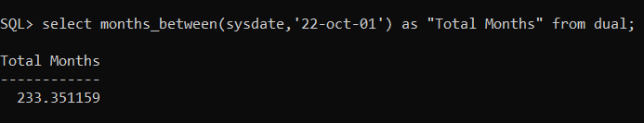

**75. Display the current date as characters/string.**

> select to_char(sysdate,'ddth Month day year') from dual;

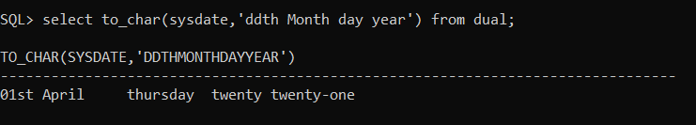

**76. Display the following output for each row from emp table. Scott has joined the company on Wednesday 13th August nineteen ninety.**

> select ENAME||' HAS JOINED THE COMPANY ON '||to_char(HIREDATE,'day ddth Month year') from EMP;

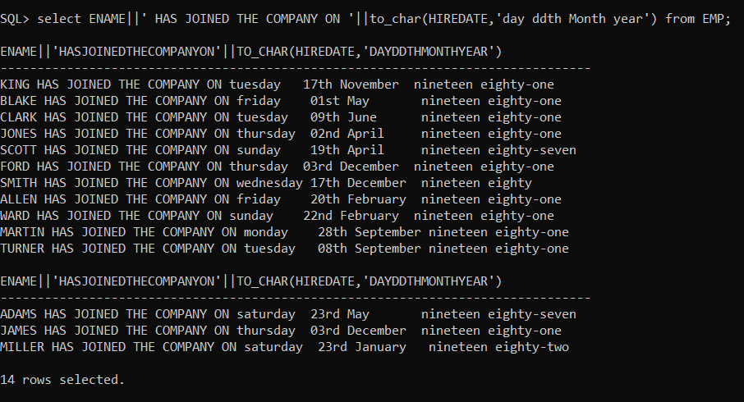

**77. Find the date for nearest Saturday after current date.**

> SELECT NEXT_DAY(SYSDATE,'SATURDAY')FROM DUAL;

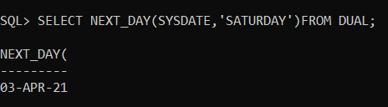

**78. Display current time**

> select to_char(sysdate,'hh:MM:ss') from dual;

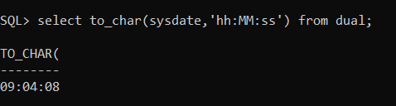

**79. Display the date three months Before the current date.**

> select add_months(sysdate,3) from dual;

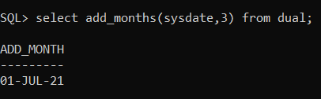

**80. Display the common jobs from department number 10 and 20.**

> select job from emp where deptno=10 and job in(select job from emp where deptno=20);

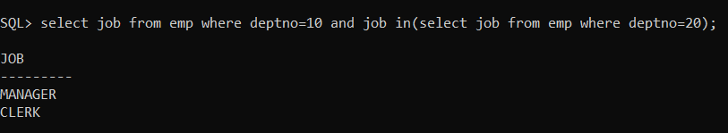

**81. Display the jobs found in department 10 and 20 Eliminate duplicate jobs.**

> select distinct(job) from emp where deptno=10 or deptno=20;

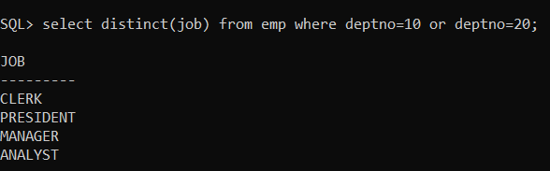

**82. Display the jobs which are unique to department 10.**

> select distinct(job) from emp where deptno=10;

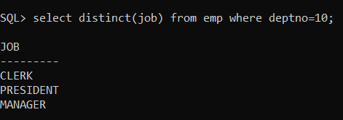

**83. Display the details of those who do not have any person working under them.**

> select e.ename from emp,emp e where emp.mgr=e.empno group by e.ename having count(*)=1;

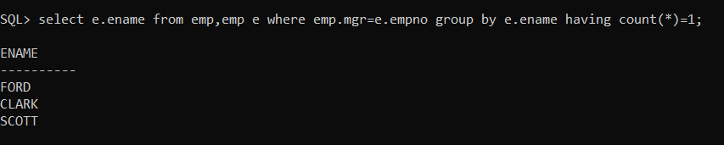

**84. Display the details of those employees who are in sales department and grade is 3.**

> select * from emp where deptno=(select deptno from dept where dname='SALES')and sal between(select losal from salgrade where grade=3)and (select hisal from salgrade where grade=3);

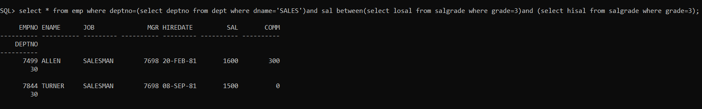

**85. Display those who are not managers and who are managers any one.**

**i)display the managers names**

> select distinct(m.ename) from emp e,emp m where m.empno=e.mgr;

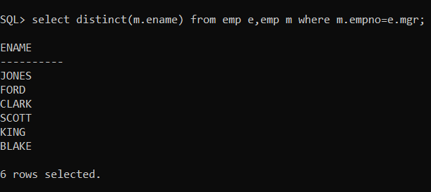

**ii)display the who are not managers**

> select ename from emp where ename not in(select distinct(m.ename) from emp e,emp m where m.empno=e.mgr);

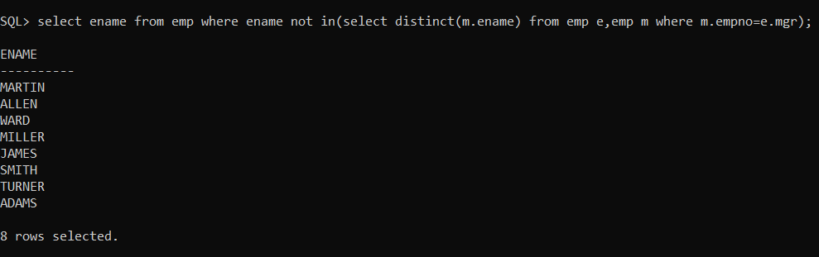

**86. Display those employee whose name contains not less than 4 characters.**

> select ename from emp where length(ename)>4;

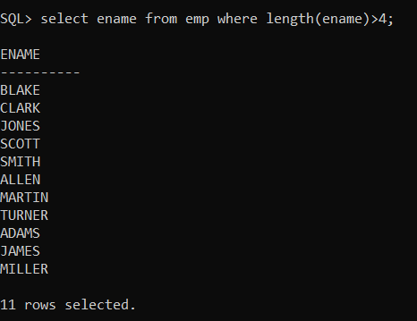

**87. Display those department whose name start with "S" while the location name ends with "K".**

> select dname from dept where dname like 'S%' and loc like '%K';

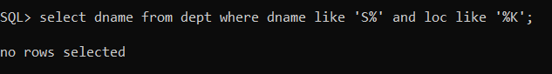

**88. Display those employees whose manager name is JONES.**

> select p.ename from emp e,emp p where e.empno=p.mgr and e.ename='JONES';

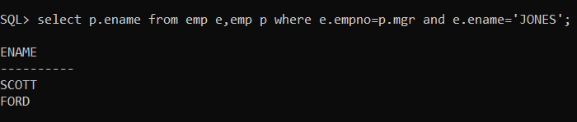

**89. Display those employees whose salary is more than 3000 after giving 20% increment.**

> select ename,sal from emp where (sal+sal*.2)>3000;

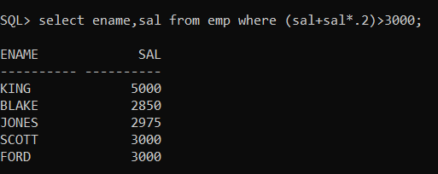

**90. Display all employees while their dept names.**

> select ename,dname from emp,dept where emp.deptno=dept.deptno;

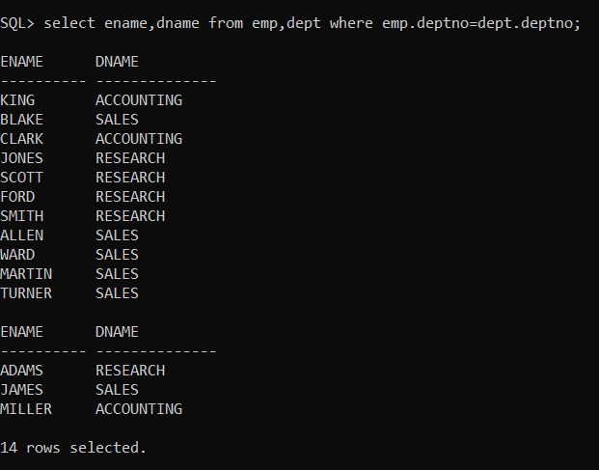

**91. Display ename who are working in sales dept.**

> select ename from emp where deptno=(select deptno from dept where dname='SALES');

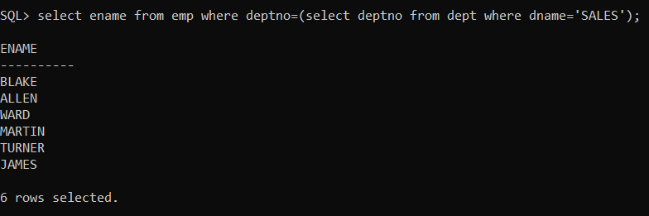

**92. Display employee name, deptname, salary and comm for those sal in between 2000 to 5000 while location is Chicago.**

> select ename,dname,sal,comm from emp,dept where sal between 2000 and 5000 and loc='CHICAGO' and emp.deptno=dept.deptno;

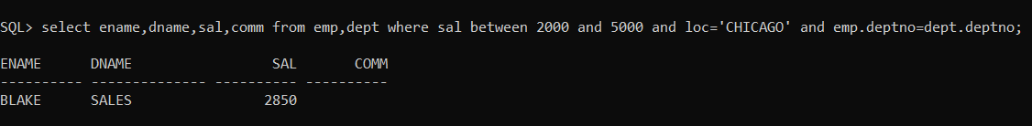

**93. Display those employees whose salary greater than his manager salary.**

> select p.ename from emp e,emp p where e.empno=p.mgr and p.sal>e.sal;

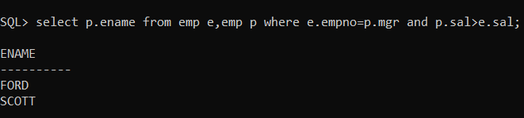

**94. Display those employees who are working in the same dept where his manager is work.**

> select p.ename from emp e,emp p where e.empno=p.mgr and p.deptno=e.deptno;

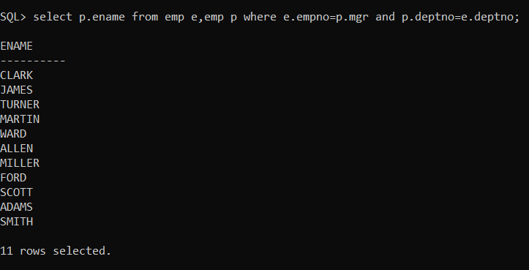

**95. Display those employees who are not working under any manager.**

> select ename from emp where mgr is null;

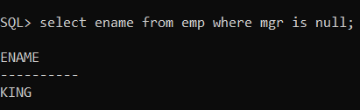

**96. Display grade and employees name for the dept no 10 or 30 but grade is not 4 while joined the company before 31-dec-82.**

> select ename,grade from emp,salgrade where sal between losal and hisal and deptno in(10,30) and grade<>4 and hiredate<'31-DEC-82';

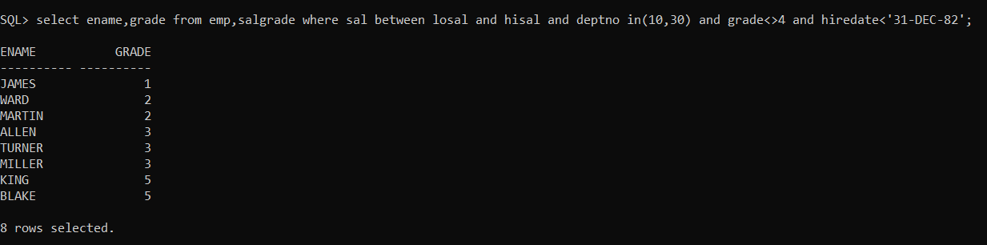

**97. Update the salary of each employee by 10% increment who are not eligible for commission.**

> update emp set sal=sal+sal*10/100 where comm is null;

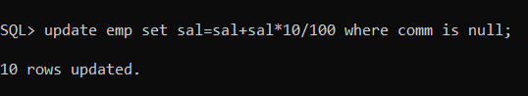

**98. SELECT those employee who joined the company before 31-dec-82 while their dept location is New York or Chicago.**

> SELECT EMPNO,ENAME,HIREDATE,DNAME,LOC FROM EMP,DEPT WHERE (EMP.DEPTNO=DEPT.DEPTNO)AND HIREDATE <'31-DEC-82' AND DEPT.LOC IN('CHICAGO','NEW YORK');

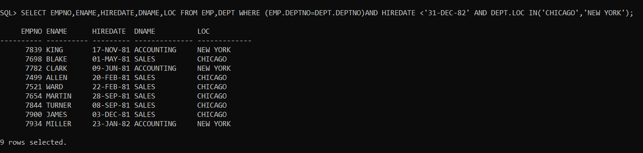

**99. Display employee name, job, department, location for all who are working as manager?**

> select ename,JOB,DNAME,LOC from emp,DEPT where mgr is not null;

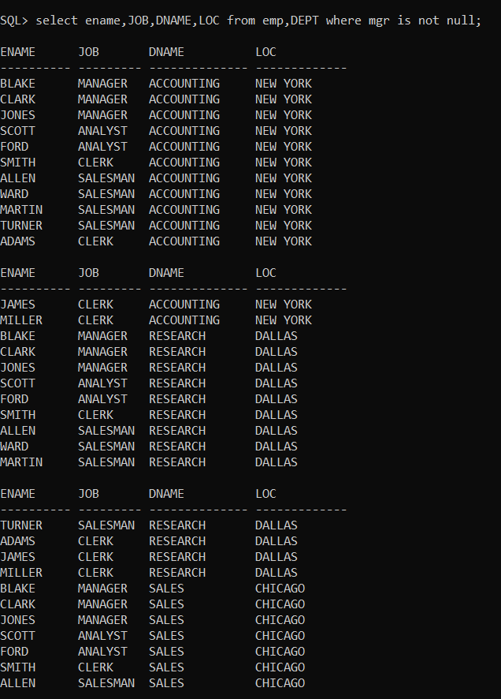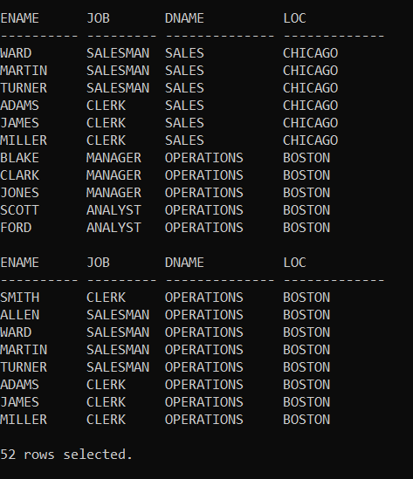

**100. Display those employees whose manager name is jones? –**

**[and also display their manager’s name] ?**

> SELECT P.ENAME FROM EMP E, EMP P WHERE E.EMPNO=P.MGR AND E.ENAME='JONES';



